M. Muntazer Mehdi

20F-0290

dEVOPS

Task 4

**Deploy Website In AWS:**

First of all, I create an account on AWS, and after sign in the main dashboard of Aws will appear which is shown as follows:

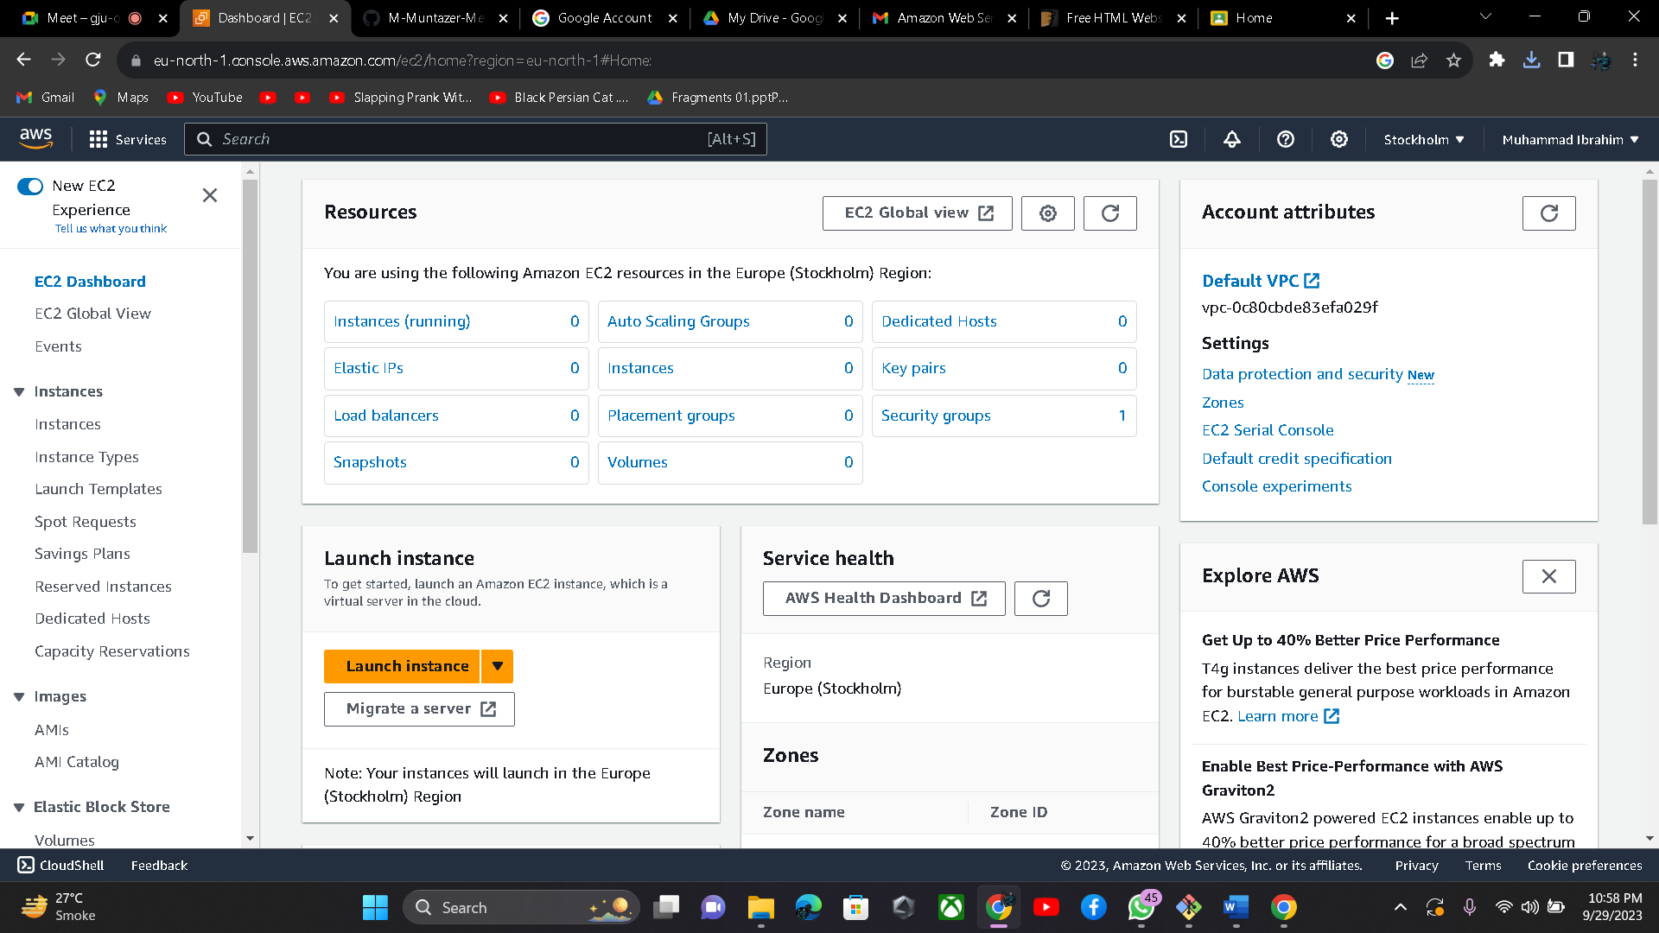

After This I will launch the instance:

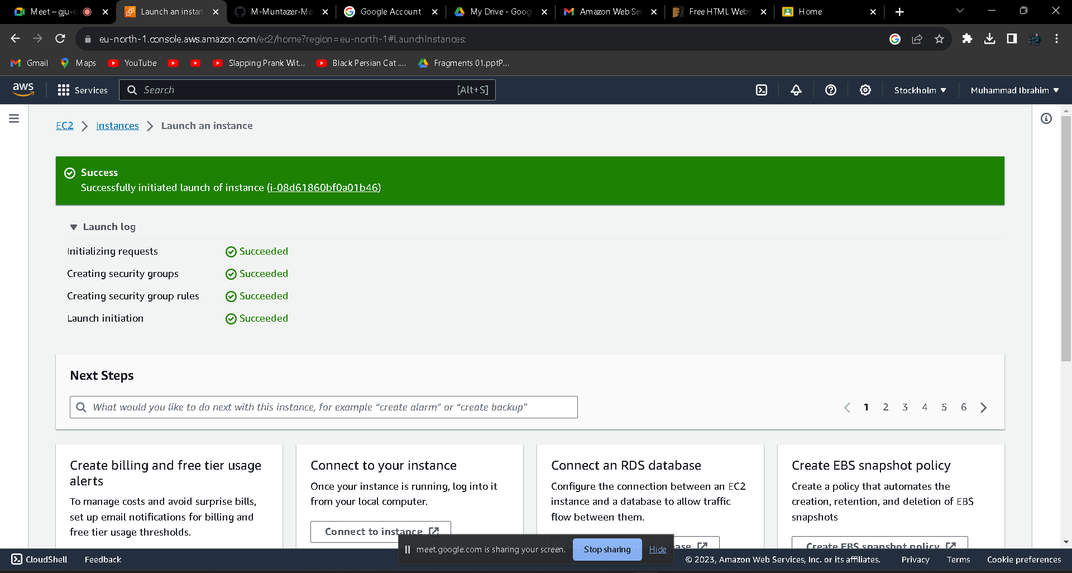

After that I will run this command to give a static IP to my index.html file:

**Output: (http://51.20.105.183/)**

